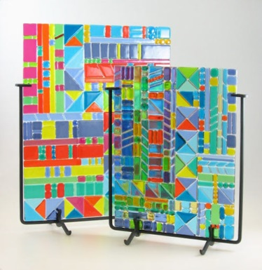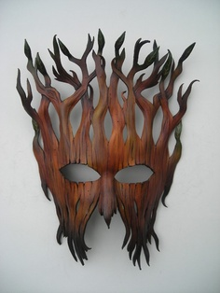

Fee and signed by: 1/23
You will need to bring a pen or pencil to each and every class. These are needed for notes and project planning.

Your class fee will cover all other class materials. The fee is $30.00, or $15.00 for reduced lunch students, or $7.00 for free lunch students. RevTrak, through Infinite Campus is the preferred payment method. If writing a check, please make it out to EHS and turn in to Mrs. Roberts by the required date. Cash is accepted and should also be brought to Mrs. Roberts. A notation of payment in the IC gradebook will serve as the receipt. If you require a paper receipt that can be done. It is vital that fees are paid by the due date so that materials can be purchased for all semester projects.

Student name (print) :_______________________________________

Student signature:___________________________________________

Parent/Guardian (print): __________________________________

Parent signature:_____________________________________________

Best contact:

Phone:__________________________

Email:___________________________
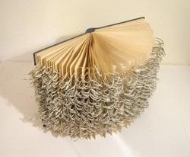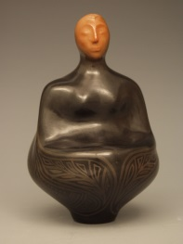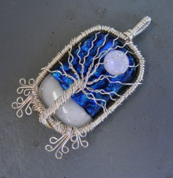

Crafts
Welcome to Crafts with Mrs. Roberts! Whether you are already an artisitc ace or a starting from scratch beginner, you will find this class to be fun and challenging. This class will focus on art objects that serve a purpose, whether it is utilitarian or ceremonial. Materials may include: warm and cold glass, metal, found objects, and leather. Students are expected to demonstrate consistent improvement in the application of skills taught, a positive attitude, and good work attitudes. This class is a prerequisite for Advanced Sculpture and Ceramics.

Classroom Expectations
Become the owner of a strong work ethic:
- Be on time and prepared for class
- Disciplined use of class time
- Constant, maximum effort
- Meet deadlines
Perfect your positive interactive skills:
  - Help keep fellow students on task
  - Maintain low noise level
  - Understand the use of empathy
  - Handle conflict constructively
Take the initiative:
  - Ask for help when needed
  - Find out what you missed if absent
  - Challenge yourself
  - Do what is expected without being told
  - Be organized
  - Help maintain the art studio

EsmART: Interested in doing more art?!? Consider joining EsmART: Erie Students Making ART. This art club will create permanent work for the school and community. Members will also get the chance to work on their own art and visit local artists, studios and galleries. We meet in T110 on Mondays at lunch as well ads Mondays and Thursdays from 2:30-3:30. Come to any or all meetings.

Contact Mrs. Roberts:
Roberts_Molly@svvsd.org
303-828-4213 ex. 45967

