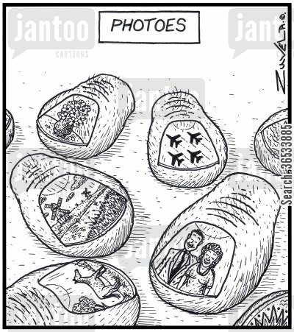

Materials and Fee Due:_____
You will need to bring a pen or pencil to each and every class. These are needed for notes and project planning You will also need a folder that has pockets and brads in the center that will secure 3-hole punched paper. If you can’t find a folder a VERY narrow 3-ring binder is acceptable. It should be no wider than 1 inch.

Your class fee will cover all other class materials. The fee is $40.00, or $20.00 for reduced lunch students, or $10.00 for free lunch students. RevTrak, through Infinite Campus is the preferred payment method. If writing a check, please make it out to EHS and turn in to Mrs. Roberts by the required date. Cash is accepted and should also be brought to Mrs. Roberts. A notation of payment in the IC gradebook will serve as the receipt. If you require a paper receipt that can be done. It is vital that fees are paid by the due date so that materials can be purchased for all semester projects.

By signing below, the student and parent/guardian accept financial responsibility for any lost or damaged equipment while in the students’ possession.

Return signed sheet by:______________________________________
Student name (print) :_______________________________________
Student signature:___________________________________________
Parent/Guardian (print): __________________________________
Parent signature:_____________________________________________

Best contact
Phone:__________________________

Email:___________________________

Beginning Digital Photo
Welcome to Beginning Digital Photography with Mrs. Roberts! Whether you are already an ace photographer or a starting from scratch beginner, you will find this class to be fun and challenging. Topics studied in this class will be: Photography history and societal influence, pivotal photographers and moments, the science and technology behind photography, and alternative processes. Students are expected to demonstrate consistent improvement in the application of skills taught, a positive attitude, and good work attitudes. This class is a prerequisite for Advanced digital photography and Beginning Studio Art: Digital media.

Classroom Expectations
Become the owner of a strong work ethic:
- Be on time and prepared for class
- Disciplined use of class time
- Constant, maximum effort
- Meet deadlines
Perfect your positive interactive skills:
  - Help keep fellow students on task
  - Maintain low noise level
  - Understand the use of empathy
  - Handle conflict constructively
Take the initiative:
  - Ask for help when needed
  - Find out what you missed if absent
  - Challenge yourself
  - Do what is expected without being told
  - Be organized
  - Help maintain the art studio
EsmART: Interested in doing more art?!? Consider joining EsmART: Erie Students Making ART. This art club will create permanent work for the school and community. Members will also get the chance to work on their own art and visit local artists, studios and galleries. We meet on Mondays and Thursdays, 2:30-3:30 and Mondays at lunch in room T110. Come to any or all meetings.

Contact Mrs. Roberts:
Roberts_Molly@svvsd.org
303-828-4213 ex. 45967

